**Kainat Shahzadi**

**Bytewise Fellow**

**What is Git??**

It’s a version control system.

* First you have to install the Git
* Then you will write some commands in git bash

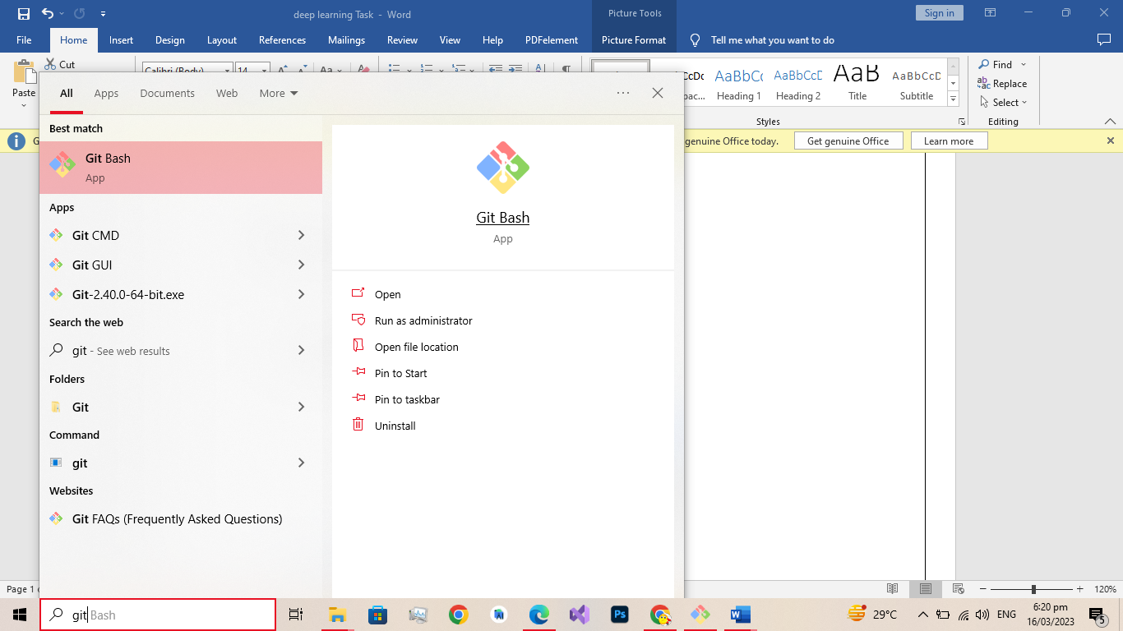

* To configuration with git use following commands.

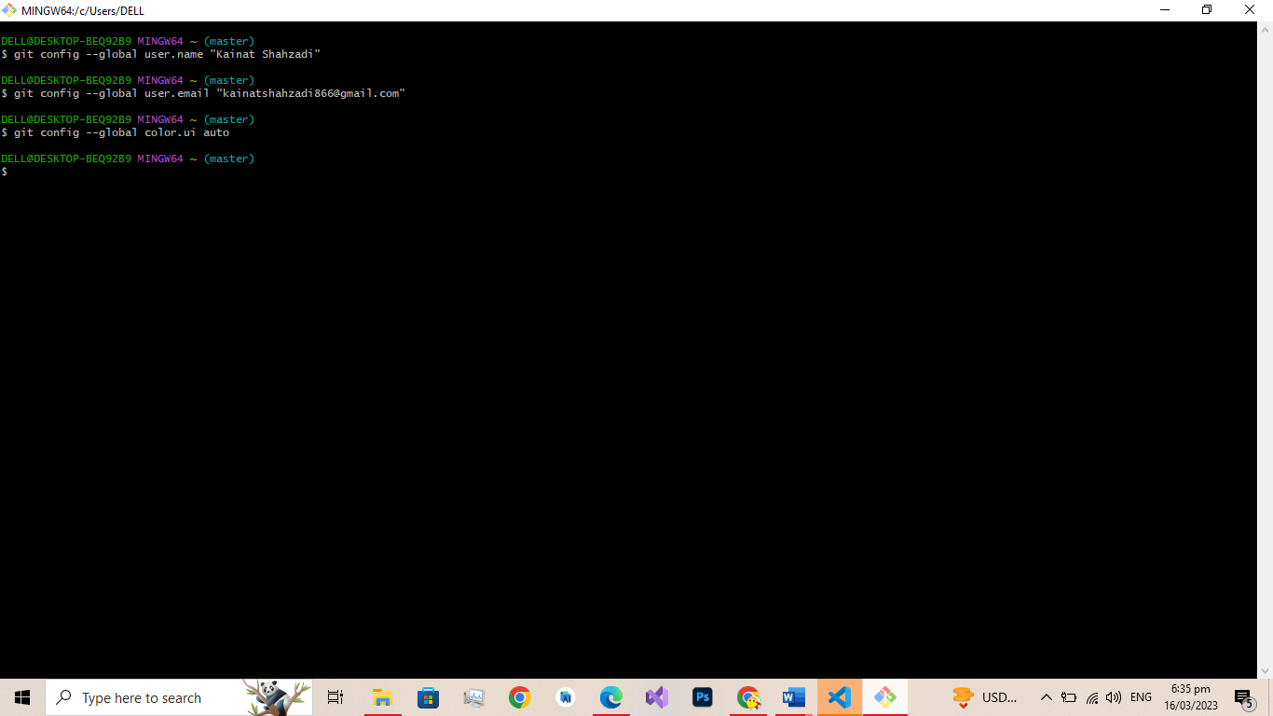

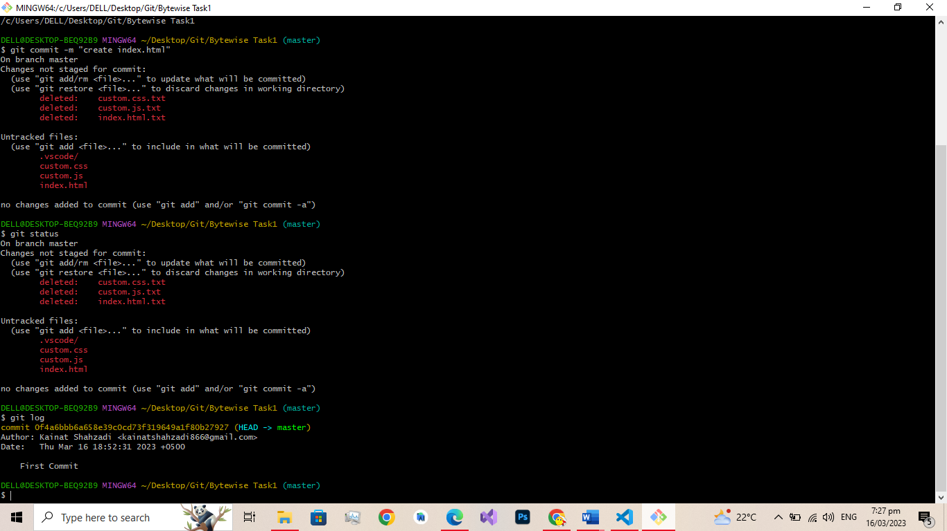

**Git init command**

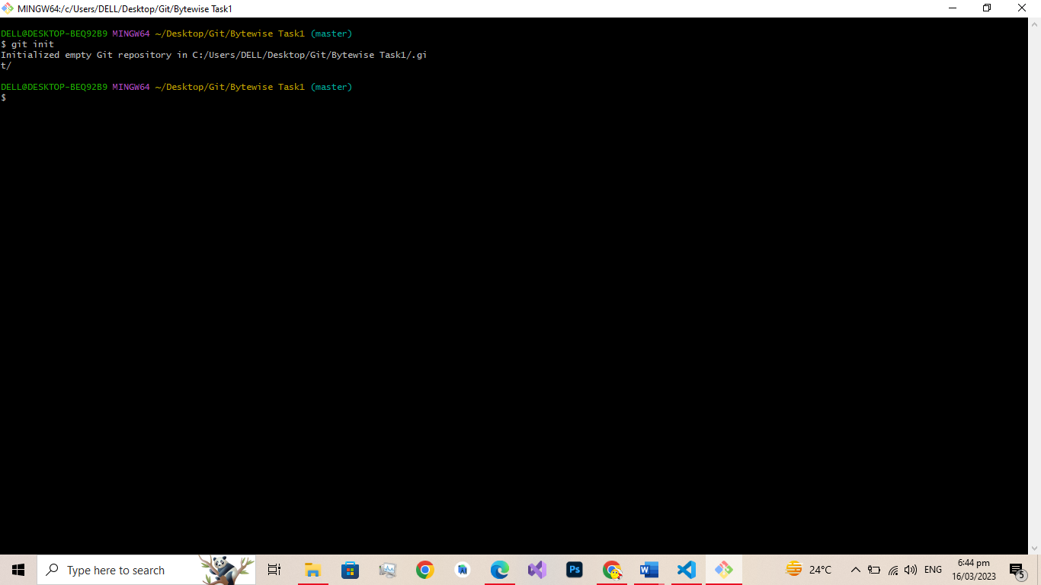

**Staging Area command (git add –a)**

**Commit Command (git commit -m “First Commit”)**

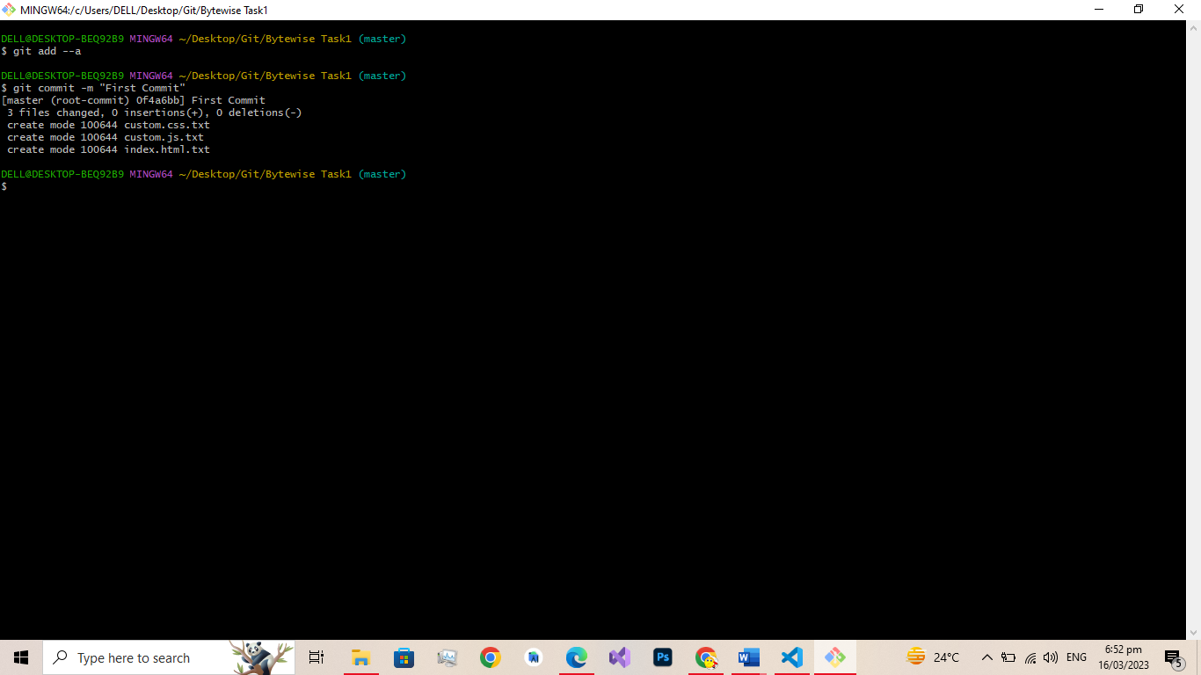

(**Code .**) Command:

Open your current project in vs code

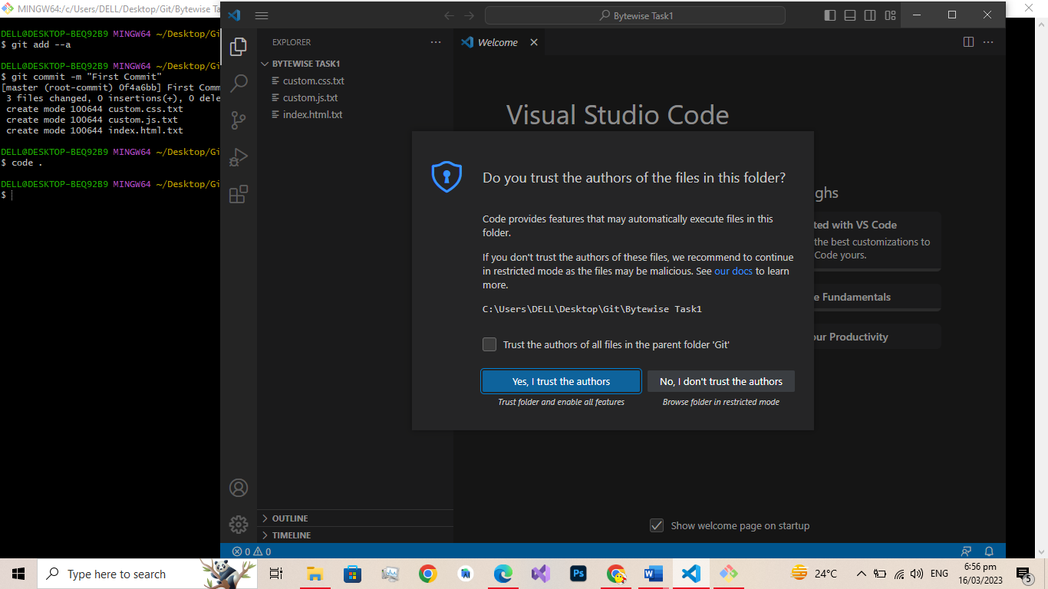

**Ls command**

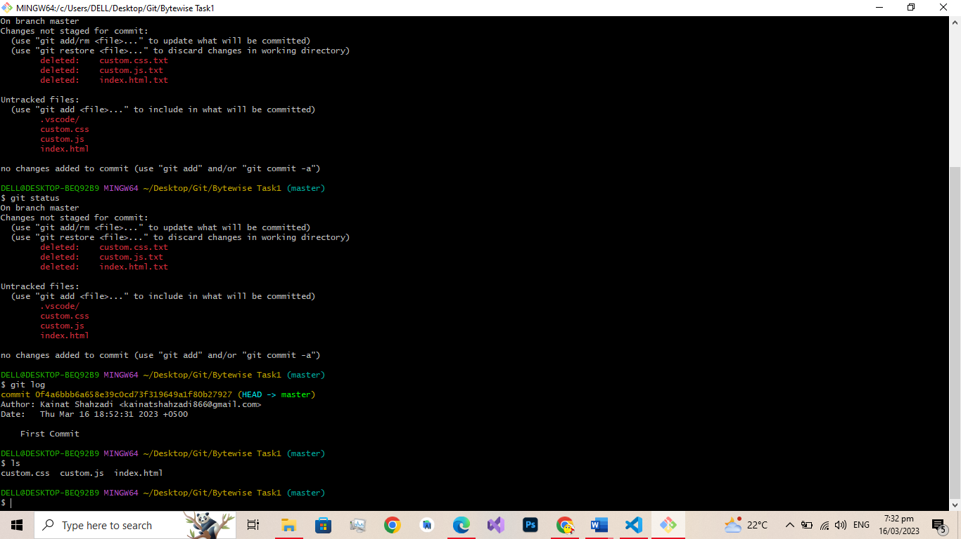

**Git in visual code**

As we have created 3 files of html, css and js and commit them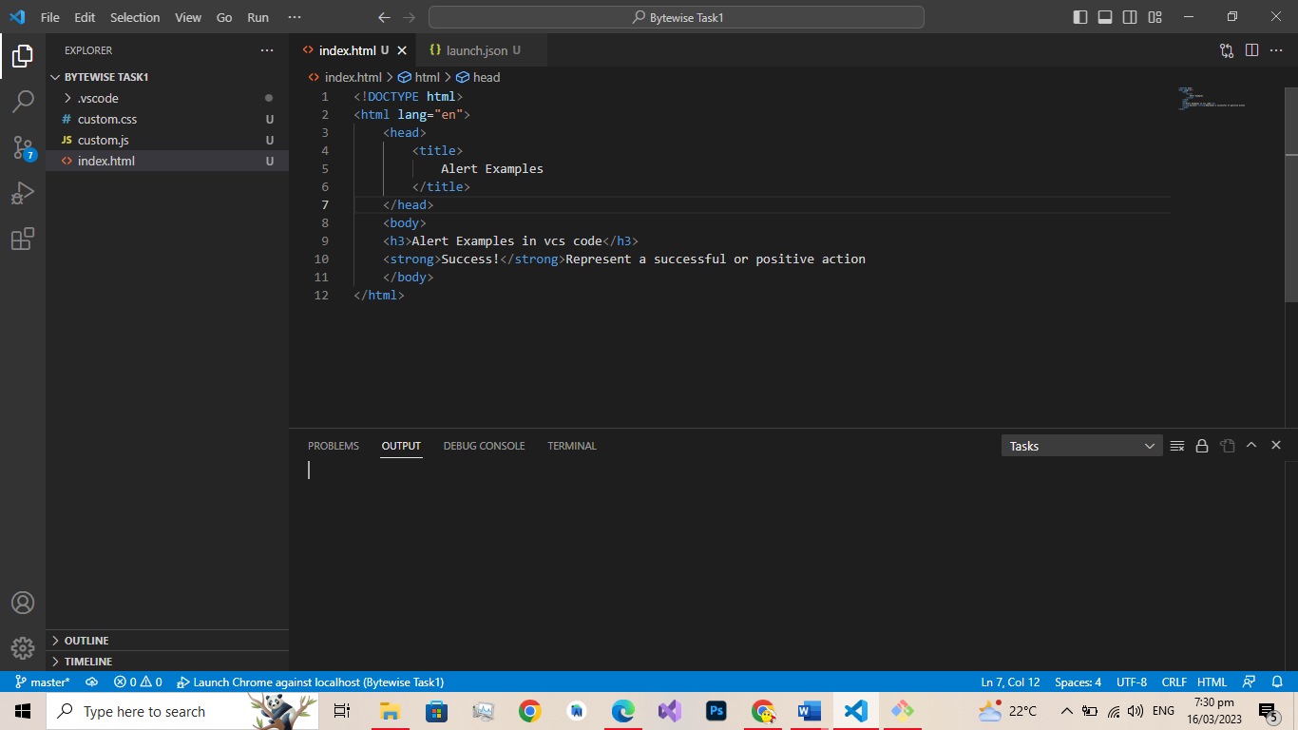

**Master branch of project**

So from here I have public my project and commit all changes to git hub directly.

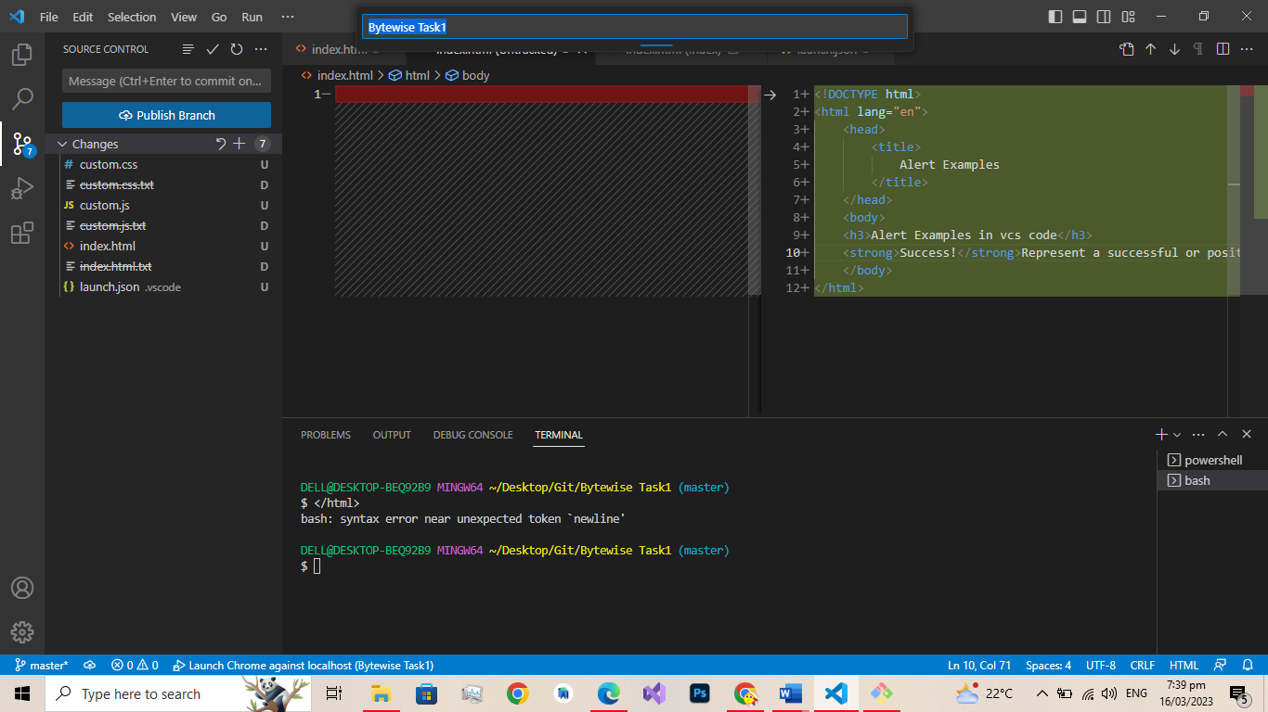

**Here is my git hub Repositry:**

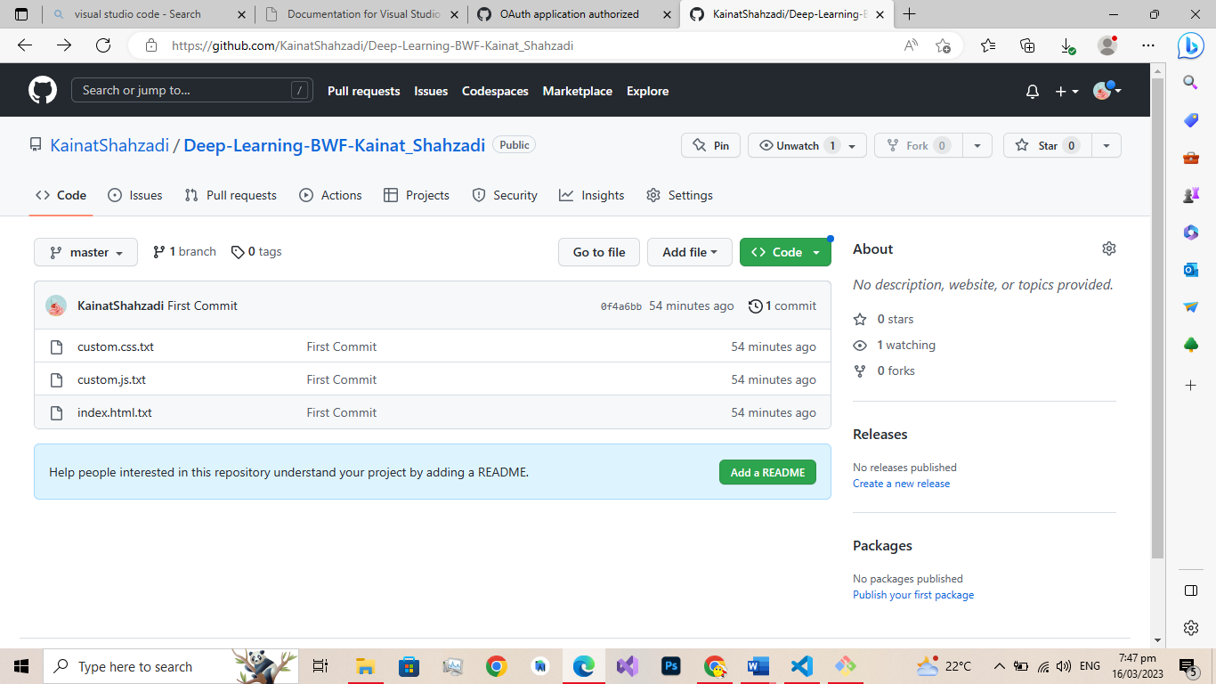

Read Me file in git Repository

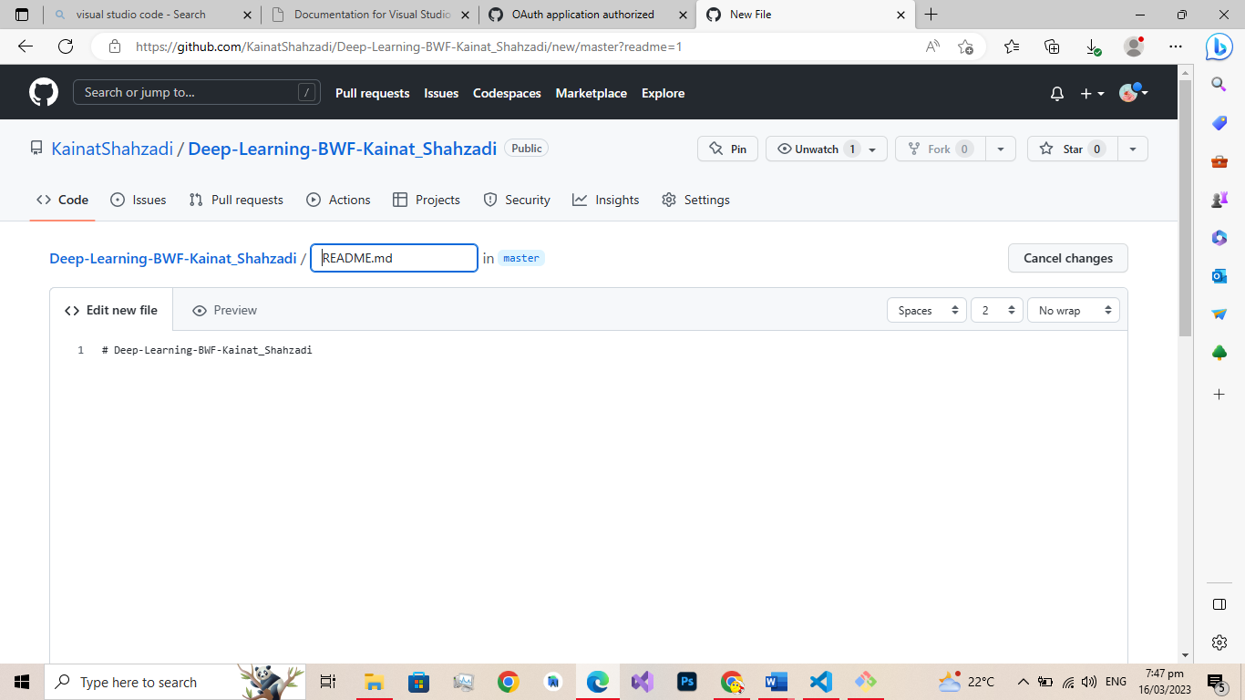

Github tasks screenshots.

